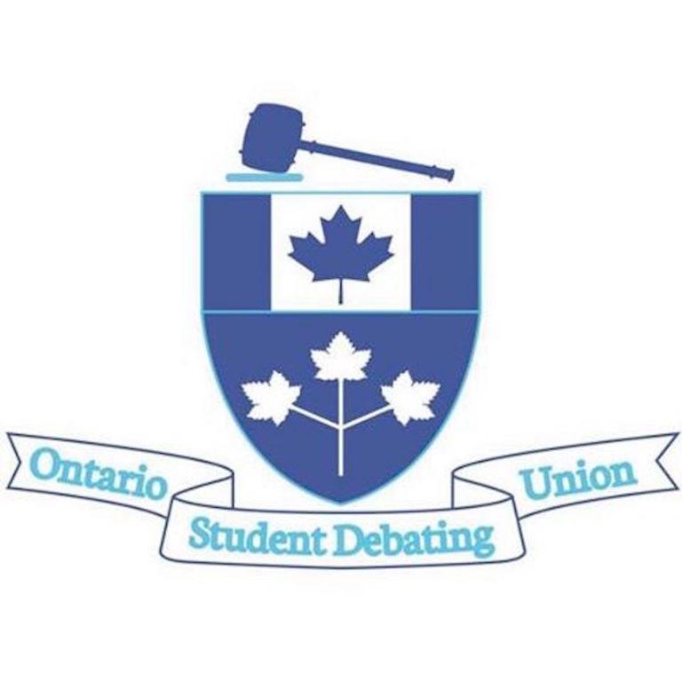
Ontario Student Debating Union
National Seminar 2021 Application

Date: September 30 – October 3, 2021
Location: ONLINE PLATFORM
**Note: There is no limit on the length of your written answers. The goal is to demonstrate why you would best benefit from the experiences at National Seminar, and why you should represent Ontario at the event. Registration information will be distributed to the successful delegates upon selection.
Please return completed form by June 5th, 2021 at 9:00 p.m. to Nicole Ratti, OSDU President at osdupresident@gmail.com

As well, please copy your supervisor/debate coach in your email. Please note that all applications must be endorsed by the OSDU member school.

Debater Information:
Name:

School:

Grade (in Sept 2021):

Language Category of Interest: English French Bilingual

Years of Debate Experience:

Contact email:

Parent Name and Phone:

Parent Email:
School Debate Coach (or contact) Name and Phone:

School Debate Coach (or contact) Email:
Have you attended tournaments in the past:

Have you ever participated in a National Debate Championship tournament (Junior, Senior, or French)? If so, which?

Have you ever previously participated in the National Seminar?
Written Answers:

- Why are you interested in participating in the National Seminar this fall?

- If you are selected to participate in the National Seminar, how will you use what you learn to enhance the debate program in your school?

- Describe one strength, and one thing you wish to improve upon when it comes to debate.

